**VISION 2020 Presented at the 2014 European Golf Business Conference   
5th – 7th November, Barcelona**

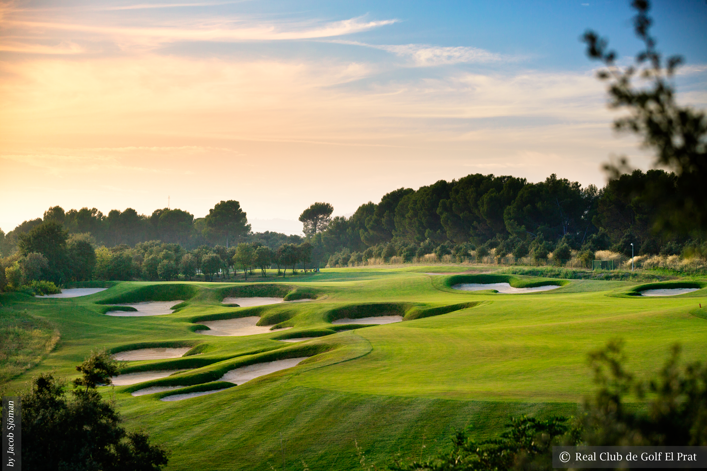

The 2014 European Golf Business Conference is headed for Barcelona, Spain. The annual event hosted by the European Golf Course Owners Association now in its ninth year, is regarded as a must attend event on the golf business calendar. 200 golf course owners, managers and industry professionals from around Europe are expected to attend the conference from the 5-7th November at Real Club de Golf El Prat & the Hotel DoubleTree Hilton, La Mola on the Outskirts of Barcelona.

The 2015 Spanish Open host venue boast 45 holes designed by Greg Norman. With over 100 years of history, the course is a truly an iconic Spanish golfing destination. Throughout the conference, networking events and the annual conference golf tournament will be held at the course. .

VISION 2020, the EGCOA’S latest research project will take center stage at this year’s event. The project’s results will be presented over the three day conference by leading industry speakers from around the world in a unique interactive fashion.

Lodewijk Klootwijk EGCOA Director said: ‘We are delighted to be headed back to Spain this year with the conference. Barcelona was an easy choice for us with its location, facilities and world renowned hospitality. Each year the conference is growing from strength to strength, last year in Lisbon we had delegates from 25 different countries with over 560 golf facilities represented.’

He added, ‘Over the last 12 months we have been looking under the hood of the European golf industry analysing past and present trends, statistics and industry data. We are very excited to share the outcomes of the VISION 2020 project which has unveiled some very interesting results.’

Early bird registration for the European Golf Business Conference is now open. For more information or to register for the event visit [www.egcoaconference.eu](http://www.egcoaconference.eu)