The effect of lowering the VAT on Golf in Holland

The sixth VAT directive of the EC has been changed several times. Around 2002 an amendment was made for sports: the reduced rate of VAT could be applied for sports. The Dutch government followed the possibility and applied the reduced rate (6%) for sports in Holland.

Effect of reduced rate

Number of players
Since the reduction in VAT the number of golf players has speeded up the growth of the number of players. This is a positive effect for the golf industry, but also for the golf players. Research proves that golf prolongs life with an average of 4 years.

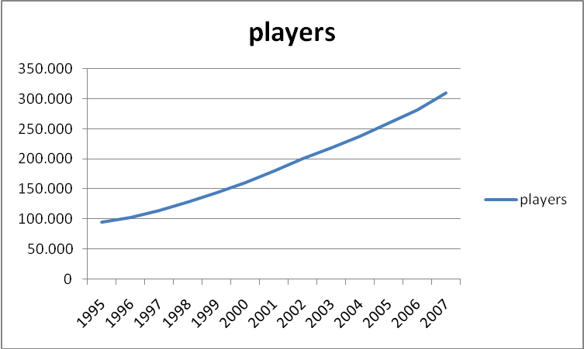

Course occupancy
The occupancy of golf courses shows a strong increase since 2002. Research by Gosta (Dutch Golf statistics, Horwath HTL) shows an increase of more than 30%:

 | 18 holes golf course
 | member owned | commerical | total average | percentage
2002 | 28.416 | 36.464 | 32.440 | 100%
2007 | 39.086 | 46.947 | 43.017 | 133%

Staff total number
More players on the golf courses means also more staff. The number of staff has increased with almost 50% according to Gosta:

 | 18 holes golf course
 | member owned | commercial | average
FTE | 7 | 11 | 9 | 100%
FTE | 10 | 17 | 13 | 149%

Staff is in full time equivalents.

Revenue golf courses
The revenue shows an increase for the commercial golf courses. Please note that on member owned golf courses 0% VAT is applicable.

 | 18 holes golf course
 | 2002 |  | 2007
 | member owned | commercial | member owned | commercial
revenues | 917 | 1285 | 1015 | 2620
expenses | 741 | 1104 | 924 | 2.332
net operating profit | 176 | 181 | 91 | 288

Conclusion

The reduced rate for VAT has had appositive influence on the development of golf in Holland. The healthy sport showed an increased growth in players. Also is proven that more people found jobs on golf courses, up till 50% increase of staff.

